Pelvic floor Workshop Info
Myths
- Leaking happens to everyone when they get older!
- After children its shot and there is nothing you can do about it!
- Its okay for tiny leaks if you sneeze, jump, laugh!
- Pain during sex is okay! N0! Hypertonic
- Doing a few squeezes every now and then will solve things
- Ignoring it and hoping for the best will solve things
Why are we bothered? Prevention it better than cure!

- urinary issues, such as the urge to urinate or painful urination
- constipation or bowel strains
- lower back pain
- pain in the pelvic region, genitals, or rectum
- discomfort during sexual intercourse for women
- pressure in the pelvic region or rectum
- muscle spasms in the pelvis
- Prolapse
Strong pelvic floor = carefree, freedom, support for organs, core and in turn lower back, better sex

What is the pelvic floor?

- Hammock for internal organs 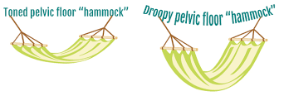
- Sufi rolls – trace the outskirts of the pelvic floor to feel quite how large it is. – review parts of the pelvis (see picture)
- Discuss the 3 main parts we will be working with
Mapping your pelvic floor (see picture) to stage 4
- External urethral sphincter – Urine control Exercise elevator &quick
- External anal sphincter – controls the exit of feces from the body Exercise elevator and quick
- Vaginal opening – reproduction, birthing, sex Exercise elevator and quick

Mapping you pelvic floor continued
- Perineal pouch (including bulbospongiosus, perineal body, superficial and deep perineal muscles and ischiocavernosus) – main function is to do with increasing orgasm, so in females these are the muscles which make the clitoris erect. They also have a supporting role.
- Levator ani (which is 2 muscles, pubococcygeus and Illiococcygeus) – support for pelvic organs and helps prevent incontinence.
- Coccygeus -support pelvic viscera but also functions to pull the coccyx forward after defecation
- Lavator ani and coccygeus are the pelvic diaphragm.
Connect breath to exercise discuss connection between the diaphragm and the pelvic diaphragm Breathing exercise – lying down
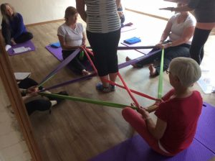
Repeat pelvic floor exercises with breath and then entire pelvic floor – hammock to trampoline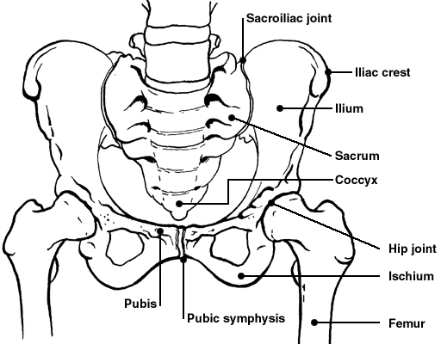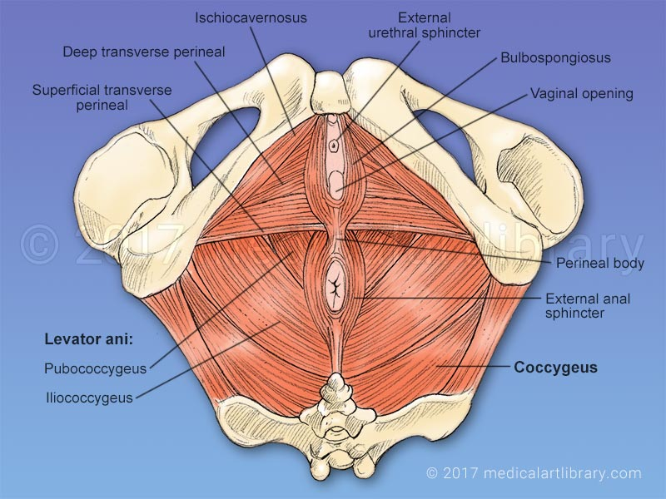
More physical exercises to strengthen

- Pelvic floor specific 3 times a day (lift and hold – up to 10, your nos how long how well. Long lifts- up to 90secs! 2-3 =set. Super elevator – L1-2-1without releasing all the way-2, 4-5=set. Protective brace/hissy lift – adds some down pressure- lift ssssssssss, feel pf meet pressure, if it goes down your protective brace not ready – increase length of ssssssssssssssssssss to build endurance)

- Bridge/wall tilts
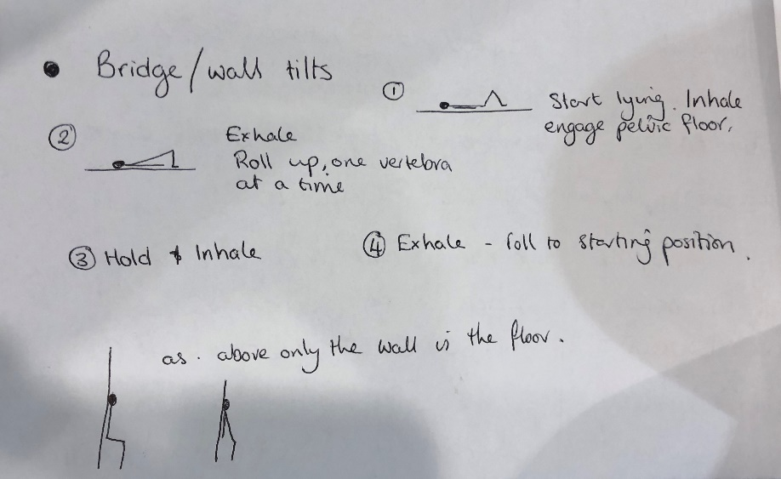

- Eagle pose – centre or wall
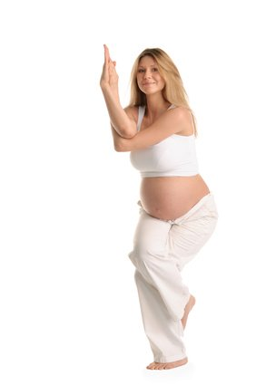

- Cross leg tabletop
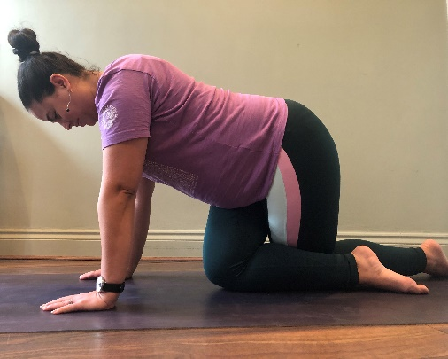
- Ball sun salute
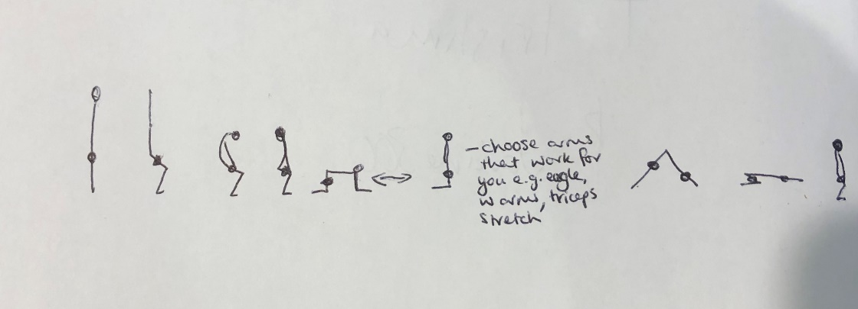

- Catcows
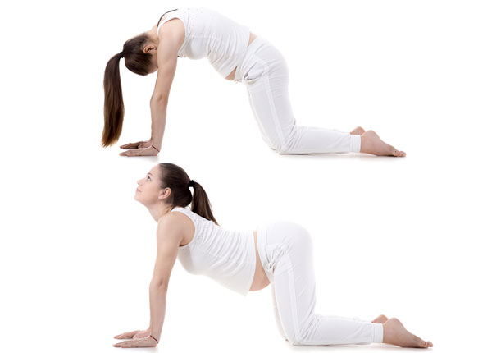
- Horse squats
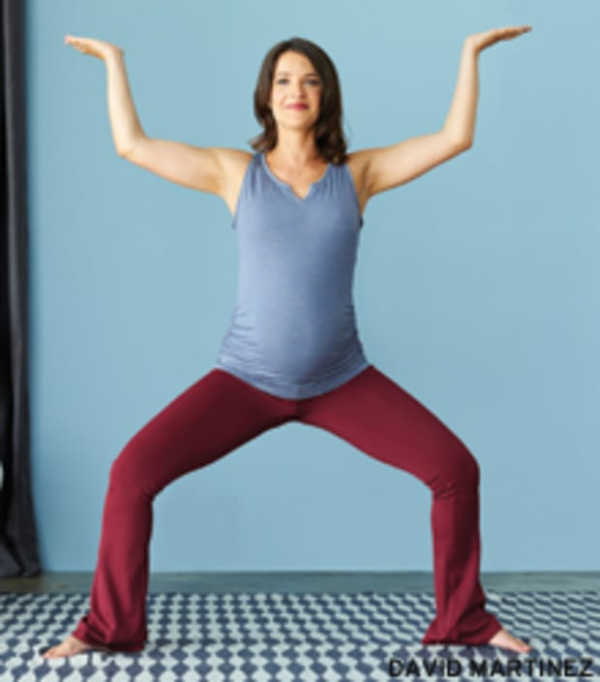
- Clams
