Chaturanga Dandasana (four limbed staff pose)
Benefits
- Strengthens the whole body
- Prepares the body for inversions, backbends and arm balances.
- Develops core stability
- Teaches us patience
- Creates focus
Common issues – things to watch out for!
- Lack of strength
- Clawed hands
- Shoulders dipping below 90 degrees
- Hips too high or too low
- Sinking into the upper back
- Relaxed legs and glutes

Alignment – Key points

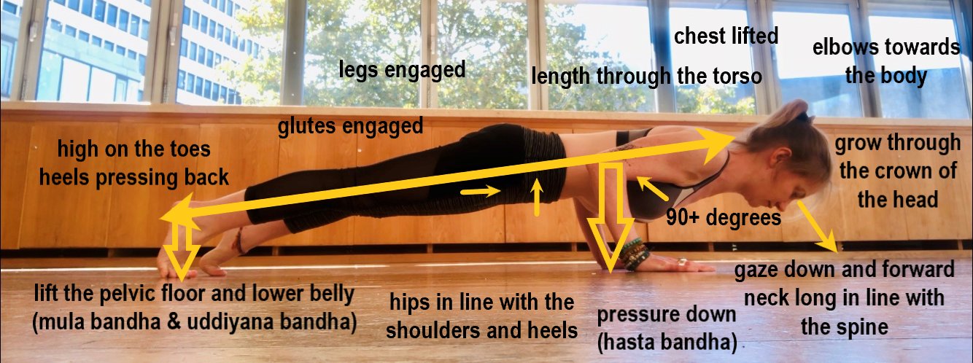
Modifications
- When working on chaturanga specifically – No knees chest chin!
- Remember to use those bandhas, mula bandha – around the pelvic floor, Uddiyana bandha – about 4 fingers down from belly button (remember the crossed elastics!) and hasta bandha – hand lock/gecko hands, all the fingers pressing down, outside of palm pressing down, petal under the centre of the palm protected by sucking up the centre of the palm.
- Stage 1 – drop the knees and supporting the body weight in the arms roll down carefully, make sure there is no tension in the lower back by slightly tucking the tail to lengthen through the lumber spine. Remember to use those bandhas
- Stage 2 – drop the knees and supporting the weight in the arms elbows drawing towards the body, keep the body in one long line as you lower, keeping the shoulders higher or level to the elbows.
- Stage 3 – Full chaturanga!

How can props help?
- Strap
  - With a strap, make a loop that's as wide as your hips. (When you hold the loop flat across your abdomen at hipbone level, it should go from one side of your hips to the other.)
  - Place it around your arms just above the elbows and come into Plank. As you inhale, reach your chest and heels in opposite directions to lengthen, then lift the tops of your thighs and direct the tailbone toward your heels. This prevents you from collapsing and activates the core.
  - As you exhale, keep the body in this position and bend your elbows until the strap catches you. Your shoulders should be at the same height as your elbows or slightly higher, so that each arm creates a 90-100 degree angle.
- Block (version 1)
  - Same alignment principles as with the strap
  - Place a block under the hips to avoid sinking as you come down. Once the hips hit the block keep everything engaged to reinforce the muscle memory as you hold.
- Block (version 2)
  - Same alignment principles as with the strap (again)
  - Place a block on its end so that as you lower down the sternum lands on the block.
  - This will act as a guide as you lower down and encourage you to continue to lift through the chest. It will also stop you from lowering too far down and compromising the shoulder girdle.
- Block (version 3)
  - Same alignment principles as with the strap
  - Place two blocks on their ends at the front of the mat, a little in front of the hands.
  - As you lower down the shoulders will touch the blocks preventing you from going too far down.
  - This version is focusing on alignment and assumes that you’ve already built the strength in the body to stay lifted and long rather than sinking in the hips or the ribs.
- Blocks (version 4)
  - All of the above!

Anatomy
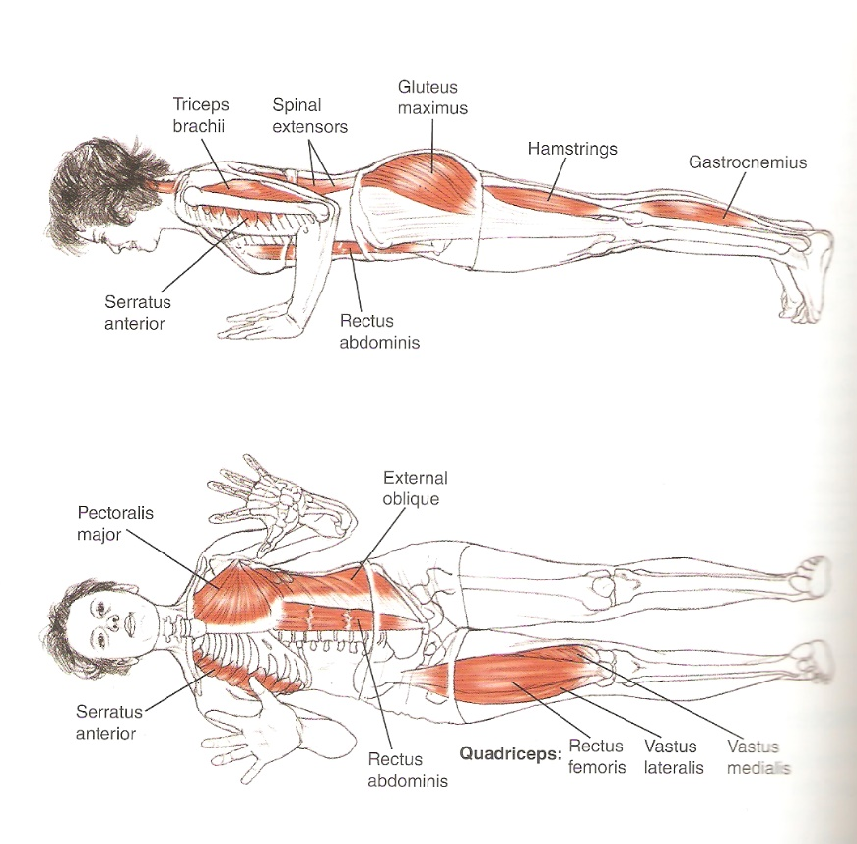
Strengthening exercises
- Holding a block above the head, squeeze the block and hold above head for 1 minute
- Holding a block above the head, squeeze the block and then keeping the block where it is and the ribs knitting in, protract and retract the shoulder blades. *protraction – shoulder blades move out around the ribs, retraction – shoulder blades move in towards each other (squeezing a pencil)
- Holding a block at shoulder height in front of you, squeeze the block and hold in front for 1 minute.
- Holding a block at shoulder height in front of you, squeeze the block and keeping the block where it is and the ribs knitting in, protract and retract the shoulder blades.
- On all fours keeping the spine in neutral and the arms straight, protract and retract the shoulder blades
- On all fours, lift the knees 1 inch off the floor and hold, keeping the shoulders wrapping around the ribs, lower.
- High plank, hold
- Dolphin plank, hold
- Lowering down in your version of chaturanga, think about keeping the shoulder blades protracted – they will move but this helps to keep the Serratus anterior engaged and strengthen.
- Wrist pronation and supination holding the blocks out in front of you. Keep the elbow creased faced up so the wrist is doing the movement *remember supination is carrying soup bowls – palms up, thumbs out, pronation – palms down, thumbs in.
- Navasana -boat pose
- Utkatasana – chair pose, squeezing the block between the thighs
- Modified sun salute squeezing the block through out.

