Active Birth and Breathing– suggested movements, pick and chose what feels right for you in the moment and remember to breathe!

Pre-Labour – erratic contractions
At this stage the most important thing is to relax and try to conserve energy – if you can take a long bath and have a bit of a sleep
- Standing an arms distance from the wall, feet hip distance apart, rest the forearms down against the wall and take the hips in circular or rocking motions. You can also lean against your partner or place your arms around their neck for support.
- Childs pose with support for the front of the body
- Modified puppy
- Walking around can help to get things going a bit faster – lean forward for contractions to help the uterus work with less resistance.
- Cat cow and rolling cat cow
Full yogic breathing – to sustain and focus, draw attention within, lower blood pressure and maintain calm. Breathe out into a contraction and focus on the exhale and then continue breathing as feels comfortable; find a rhythm.
3 part breath - breathing into the belly, then drawing a little more breath into the ribcage, allowing the ribs to widen all the way up to the collarbone. Exhale from the top downward, let the air out from the ribcage, allow the ribs to slide closer together and the belly to deflate, gently drawing the navel towards the spine. The benefits are similar to those of other deep-breathing techniques which, while calming the mind and relaxing the body, slow the heart rate and have a calming effect on the central nervous system. They also oxygenate the blood and purge the lungs of residual carbon dioxide.
Humming breath - If in doubt breathe out! The out breath is the antidote to pain. If massive contractions and you can't help but hold your breath, use sound to help you exhale. Breathe into your partner's hands. Your partner puts their hands on your lower back; you breathe 'down your back' and 'into your partner's hands'.

Once you are having 3 contractions lasting 40 seconds or more over 10 mins this is the time to call the midwife/hospital

1st stage labour – a rhythm has formed to the contractions and they are at regular intervals
Its important not to tire yourself out too much at this point so take rest frequently and as the contractions get closer together just rest between them. Aim to keep the torso quite upright so gravity can assist you. In very intense contractions or if you are exhausted allow yourself to have the head down e.g. modified puppy
- All of the above movements can also be used in this stage
- Side lying with support
- Kneeling, resting forward on a ball and swaying side to side/ circling
- Sitting legs wide lean on ball (like we do with the bolsters at the end of class)
- Sitting backwards in a chair and leaning on the back
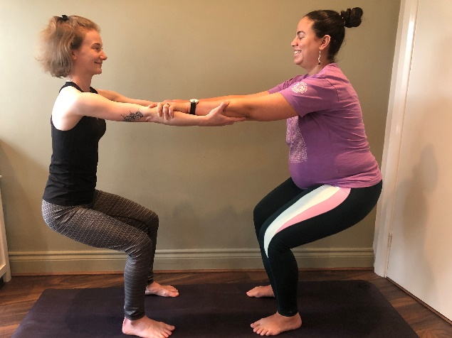
- Supported squat (partner squats) -keep the hips higher than the knees at this stage
- Chair at the wall
- Camel walks (step forward, scoop pelvis forward, step forward other foot, scoop, repeat)
- Half kneeling, half squatting (from hands and knees bring one foot to the outside of the hand and either keep the hands on the floor or lean against a piece of furniture or your partner.
- Yogi squat – rocking side to side

It’s tempting to start to breath too quickly at this stage so your partner can lead you to take slower breaths by breathing with you.
Horse breath - If you find your jaw tensing up, you can exhale like a horse through flapping lips. Aim to make a sound, resonating the air between your lips.
Blowing out the candles - When expansions come that are sharper to handle, breathe out with small out breaths through the mouth, as if you are cooling some soup or blowing candles out.
Golden Thread Breath - The purpose of this breath is to block the pain receptors in the brain, by re-focusing the mind on visualising a golden thread. Use your imagination with this. You can visualise a thin golden thread, a big fat golden ribbon, golden light spiralling from the mouth etc.
Lips barely apart, breathe in through nose and out through lips. Fine, long, thin breath; the longer the breath the farther out you follow it. The farther out it spins, the more focused the mind needs to be; the more focused the mind on the out breath, the more powerful the antidote to pain.
Sounded breath – e.g. ssssshhhhhhh, hhhhaaaaaaammmmm, rrraaaaaammmmm, ooooooohhhhhhmmmmmmmmm.
Transition
It can be very tempting to start pushing during this stage while the cervix fully opens, once the midwife can no longer feel the cervix you are ready to go. There may be an anterior lip (where the cervix at the front is not quite out of the way of the baby’s head) if this happens try and be patient and come into modified puppy to reduce the urge to push until the body is ready.
- Any of the previous positions that have been helpful so far, most commonly kneeling or standing resting on something in front of you is the most comfortable but if that doesn’t work for you listen to your body – this is the time to let your body start to take over slightly so you can relax as fully as possible to let the cervix fully open.
Full yogic breathing – to sustain and focus, draw attention within, lower blood pressure and maintain calm. Breathe out into a contraction and focus on the exhale and then continue breathing as feels comfortable; find a rhythm.
Golden Thread Breath - Lips barely apart, breathe in through nose and out through lips. Fine, long, thin breath; the longer the breath the farther out you follow it. The farther out it spins, the more focused the mind needs to be; the more focused the mind on the out breath, the more powerful the antidote to pain.
Vocalise – whatever sounds want to come out let them e.g groans, moans, oooohhhs and aaahhhs

2nd stage labour (birthing the baby)
- Cat pose
- From hands and knees step one foot forwards, rock forwards and backwards or circle the hips.
- Supported squatting -on each contraction your partner holds you close and holds the majority of your weight, just let the knees bend as low as you want to and the weight to be supported as the contraction happens and then go back to moving freely. You canbe supported from the front holding on to your partners neck and from behind with your partner holding you under the armpits.

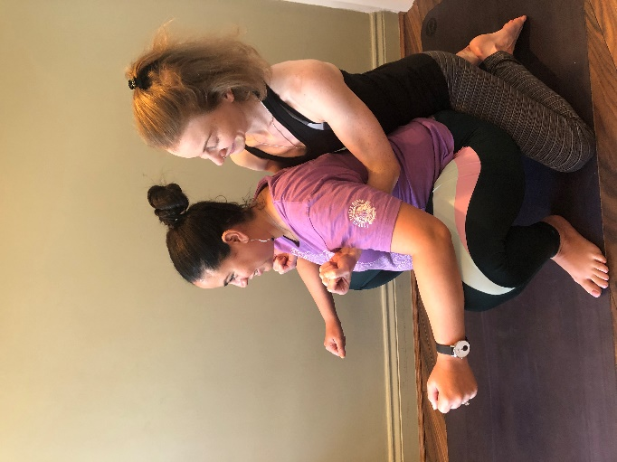
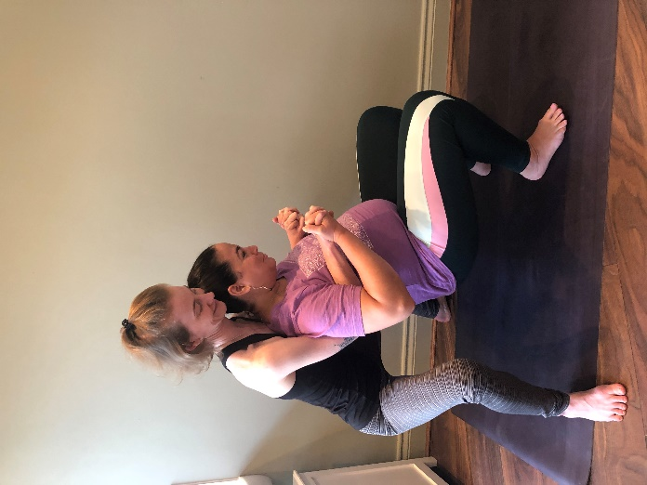
The longer you can extend the breath out, the further the baby is able to move down the passage during one contraction.
Birthing Breath (Cafetiere Breath) - With the birthing breath, you allow your conscious awareness to descend down the body with each out breath. Begin by taking an in breath as deeply as you can and focus on moving down your spine on the out breath. Wherever your mind focuses at the end of your exhalation is where you begin from with your next inhalation. Keep moving down the body with each out breath until you are focused in the cervix, birth canal and perineum. This is where you focus on expanding with each forthcoming exhalation.
You are effectively using your out breath as you would the plunger of a cafetiere. The diaphragm works with the abdominal muscles, pushing down on the uterus and expanding (relaxing) the pelvic floor muscles to ease your baby through the birth canal gently.
Try voicing your breath with a 'haaah' sound that feels good and helps abdominals work with bearing down contractions. Extend the exhale as long as you can to increase the pressure of your uterus.
This breath can also be used when birthing the placenta.
Crowning - break from pushing, you can lightly use the blowing out the candles breath - very gentle and soft small out breaths, to help disengage abdominal muscles from pelvic floor.
Just remember – Breathe baby out!

3rd stage labour (birthing the placenta)
If possible allow this to happen spontaneously as there is much less chance of any part of the placenta being retained.
- When you feel the contractions coming on you can assume a supported squatting position to allow the placenta to come out.
- Another option is to sit in butterfly pose with the feel together and the knees dropped out to the side and lying back onto a pile of cushions so the back is slanted – think golden chair but with the knees dropped out to the side.
First hour after birth and for 2 weeks after (couple of times a day)
Basic Reverse Breath - Apply this breath after birthing the placenta, and also for the first two weeks, several times a day, to restore muscles, uterus and pelvic alignment.

Begin by taking an in breath and feeling it rise from the base of your body upwards. As you begin to exhale, draw the abdomen in towards your spine and up towards your chest. Prolong the exhalation and movement as long as comfortable and then gently release abdominal muscles before the next inhalation.
Each exhalation should be longer than the inhalation but never forced.
Once bleeding has stopped, include lifting the whole of the pelvic floor upward as you draw your abdominal muscles in and up.

Acupressure points for birth
All these points are suitable to start from 37 weeks to help the body start moving towards the birth. Press only softly during the last few weeks but during the birth press quite hard.
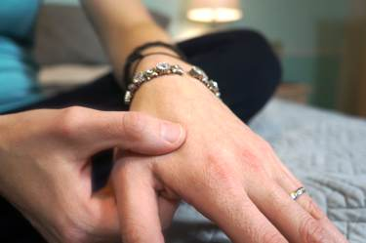
This point is great to help get things started and the woman is able to press this point herself. It’s generally helpful for her to start pressing this point at the beginning of birth (or even before it begins in the last couple weeks of pregnancy). This point is often useful when the woman starts to get the urge to push.

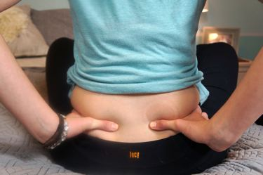
The lower back points are extremely helpful if you are experiencing back labor or in the middle of an intense contraction as a counter pressure. These points are in the lower back region and can be individualized to the woman depending on where it feels the best to her. Sometimes the point might be more outwards on the lower back. Have your support person push into the points with their knuckles and lean in with their body weight during a contraction.


This point is located in the centre of sole of the foot in the depression next to the bottom of the ball of the foot. These points pull energy downward and are typically useful during the transition phase of birth. This is also a great point for calming to help with stress and anxiety. You can also use travel sickness bands around the foot to place the pressure on the point for you.

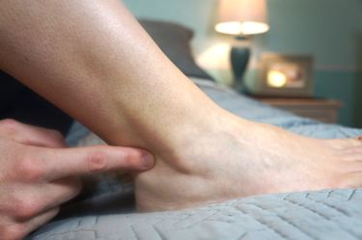
This point is generally used to increase circulation and provide pain relief in the body. Most women also like this point during the transitional phase of birth.

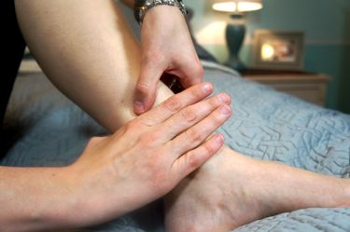
This point is located on the inner calf about four fingers width up along the tibial bone. There will be a tender spot, so find that. In case of a stalling labor, use this point along with large intestine 4 to encourage stronger contractions. Have the woman apply pressure to the hand point and the support person give acupressure to spleen 6.

You’ll have to experiment with each of these points to see which ones feel the best. What felt the best during pregnancy might not be the one that feels the best during the birth and they could also change depending on what phase of the birth you’re in.

